Hazard Resources
The structure of the training software could be something like:
- Hydrogen fundamentals ( this can be our homepage/landing page)
- Flammability and ignition
- Pressure systems (low vs high)
- Leak detection and response
- Ventilation and dispersion
- Fire risks (invisible and autoignition flame jets)
- Emergency procedures
- Application-specific risks (lab, transport, cryogenics)

H2O2 ratios for ignition:
- All fires require 3 things:
  - A fuel (in this case H2)
  - An oxidiser (in this case O2)
  - An ignition source
- H2 has a large flammability range in air, with concentration of ~4-75% allowing for combustion
- <4% leads to a H2 concentration that is too lean to ignite while >75% is too rich
- The stoichiometric ratio for ideal ignition is where the ratio of H2 to O2 in the air matches that of the ratio for complete combustion 2H2+O2->2H2O
  - This corresponds to ~30% H2 in air
  - This results in the fastest flame speed, the maximum energy released and the highest explosion pressure
- The most dangerous time when hydrogen leaks from a source is during mixing, where the ~4-75% H2 concentration is most likely to occur

H2 sensor identification:
- Look for small devices labelled “H₂ detector” , “Hydrogen sensor” or “Gas detector”
- They are often connected with alarm beacons and sirens
- Labs with sensors installed typically have control panels near the entrances that show a gas detection panel, gas concentration levels and/or alarm status
- Signage such as “Hydrogen in use” or “Gas detection system installed” may be present on the lab entrance door
- Hydrogen detectors are mounted high-up or on the ceiling directly
  - This is because hydrogen is 14x lighter than air, meaning it will gather at the highest points in an enclosed space
- Other common mounting points include directly above equipment utilising hydrogen, above storage devices and above electrolysers
- The most effective way to locate H2 detectors is to visually scan the lab ceiling or ask the lab manager about their locations

High pressure vs low pressure:
Hydrogen is typically compressed at varying pressures to enable continuous supply. Storage pressure brackets can be broken down as follows:
- Low pressure
  - <20 bar
  - Typically seen in lab experiments, fuel cell test setups, and electrolyser outputs prior to compression
  - Lower risk profile due to a lower amount of stored energy in a tank, quick dispersal of leaks and a leak lower autoignition risk
  - Key hazards include accumulation in confined spaces and flame/explosion risk
- Medium pressure
  - 20-350 bar
  - Typically seen in industrial gas systems, pre-compression storage chambers
  - Higher risk due to increased amount of stored energy, potential for significant jet release with autoignition and equipment rupture risk
  - Key hazards include those above plus explosive equipment failure
- High pressure
  - 350-750 bar
  - Typically seen in hydrogen vehicle storage systems (passenger =700 bar, heavy duty/truck = 350 bar), high pressure storage tanks and hydrogen refuelling stations
  - High risk profile due to high amount of stored energy, potential high-velocity jet leaks with autoignition and risk of explosive equipment failure
  - Key hazards include those above plus hydrogen embrittlement of storage equipment

Training Scenarios:
- Hydrogen stored at low pressure in a lab
  - Hazard: Hydrogen accumulation in an enclosed space
    - Identification:
      - Hydrogen sensor(s) alarm sounding
      - Little/no ventilation in the lab
      - Hissing sound coming from storage device
      - Unexpected/unexplained pressure drop in storage device
    - Mitigation:
      - Ensure ventilation measures (windows, fume hood, vent fans) are active/open in the lab
      - Regular inspection of hydrogen storage devices by noting pressures
      - Regular inspection of fittings and pipes for leaks by spraying with soapy water
      - Evacuation protocols in place if leak is detected without knowledge of concentration in air
- Hydrogen stored at high pressure in a lab
  - Hazard: Hydrogen accumulation in an enclosed space, tank rupture, high-velocity jet release leading to fire/explosion due to autoignition
    - Identification:
      - Look for storage devices labelled as high pressure (350/700 bar)
      - Look for storage devices fitted with pressure relief devices
      - Use thermal imaging devices to identify leak jets
      - See training scenario 1 above
    - Mitigation:
      - See training scenario 1 above
      - Inspect tanks for any damage to the outer fiberglass layers
      - Notify lab custodian if any tank damage is observed even if no hydrogen leaks are detected
      - Sound alarm and evacuate immediately if hissing is heard due to the ability of high-pressure hydrogen leaks to auto-ignite
- Invisible hydrogen flame in the lab due to leak
  - Hazard: Risk of walking into a hydrogen flame due to its near invisibility in daylight
    - Identification:
      - Heat shimmer in air
      - Roaring sound
      - The use of thermal imaging cameras
      - Automated IR flame detectors in the lab sounding an alert
    - Mitigation:
      - Automated IR flame detectors in the lab
      - If a suspected leak is to be approached, it must be done cautiously and preferably with the use of a thermal imaging camera
      - Include remote shutoff systems in the hydrogen storage system design
- Hydrogen accumulation detected in an enclosed space
  - Hazard: Asphyxiation if space is entered, explosion if an ignition source is introduced into the space
    - Identification:
      - Hydrogen detectors mounted high up or on the roof
      - No ventilation present in the enclosed space
    - Mitigation:
      - Ensure all areas with hydrogen storage devices and piping is well ventilated
      - Ensure an evacuation procedure is in place if hydrogen accumulation is detected
      - Ensure hydrogen detectors are placed in all high-up areas in and around locations where hydrogen is stored/used
- Use of cryogenic/liquid hydrogen
  - Hazard: Extreme cold, material embrittlement, boil-off gas
    - Identification:
      - Tanks marked with cryogenic safety signs
      - Frost buildup around tank fittings
    - Mitigation:
      - Use of gloves specifically rated for cryogenic work and a face shield is essential
      - Only use liquid hydrogen in areas with ventilation, lest the above hazards must be accounted for due to boil-off gas

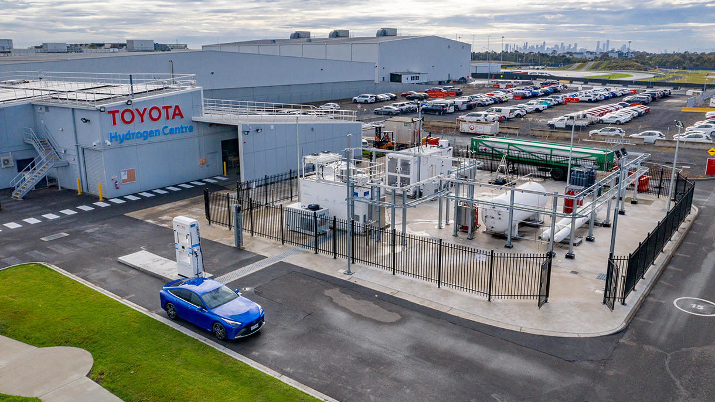
https://scifleettoyota.com.au/blogDetails/Toyota-Unveils-Victoria-s-First-Hydrogen-Production-and-Re-Fuelling-Facility-Facility-at-Centre-of-Excellence/965

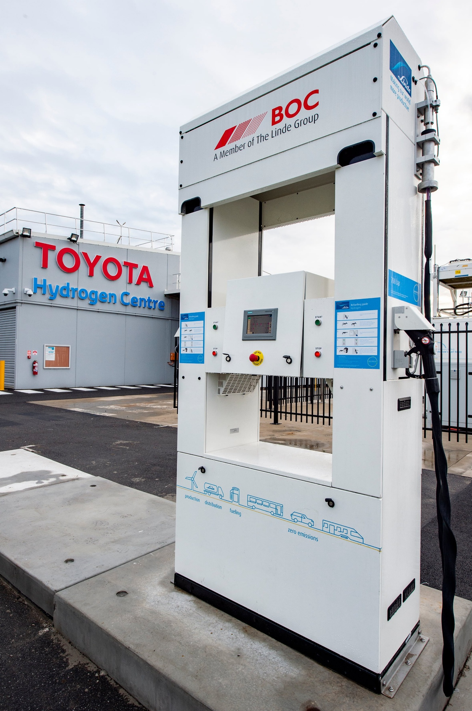Creator: Joel Strickland
Copyright: Joel Strickland

